Evidencia

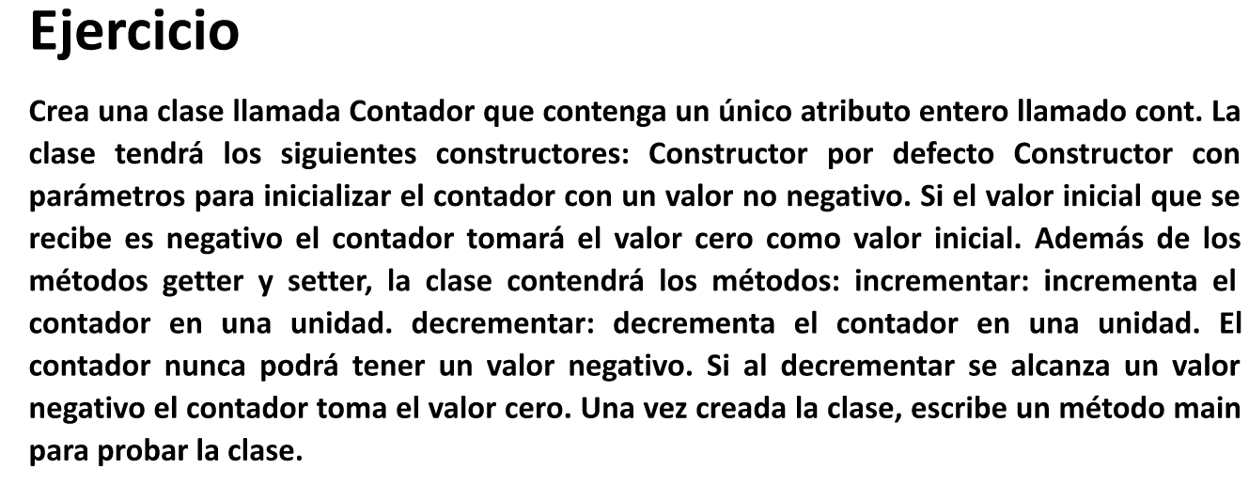

package contadorprincipal;

import java.util.Scanner;

/\*\*

\*

\* @author quiro

\*/

public class ContadorPrincipal {

/\*\*

\* @param args the command line arguments

\*/

public static void main(String[] args) {

// TODO code application logic here

Scanner leer = new Scanner (System.in);

System.out.println("Ingrese valor inicial:");

int ContInicial = leer.nextInt();

Contador C1 = new Contador(ContInicial);

System.out.println("Ingrese Opcion 1:Incrementa 2: Decrementa");

int op = leer.nextInt();

if (op == 1) {

C1.incrementa();

}

if (op == 2){

C1.decrementa();

}

System.out.println("Valor contador :"+C1.getCont());

}

}

package contadorprincipal;

/\*\*

\*

\* @author quiro

\*/

public class Contador {

private int cont;

public Contador ()

{

}

public Contador(int cont){

this.cont = cont;

if (this.cont < 0){

this.cont = 0;

}

}

public int getCont()

{

return this.cont;

}

public void setCont(int cont )

{

this.cont= cont ;

}

public void incrementa(){

cont = cont + 1;

}

public void decrementa(){

cont = cont -1;

}

}